Scroll down to the login page bottom

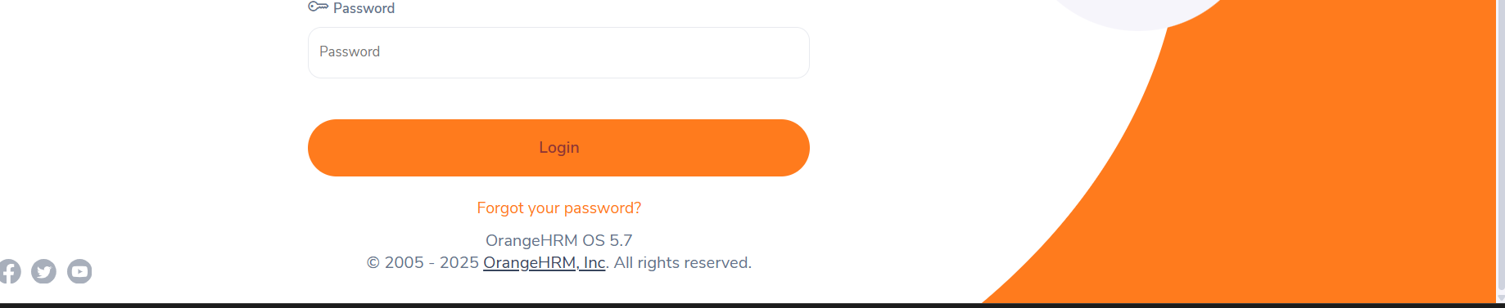

1. Click on social media icons (LinkedIn, Facebook, Twitter, YouTube)

